Creative Commons
Attribution Game

To win
You need to have
- Title
- Author
- Source
- Licence
from the same suit (i.e. they have the same picture). You can use cards in your hand and cards on the table.
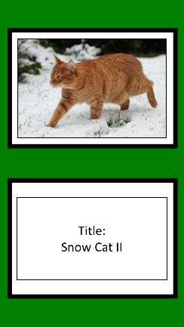
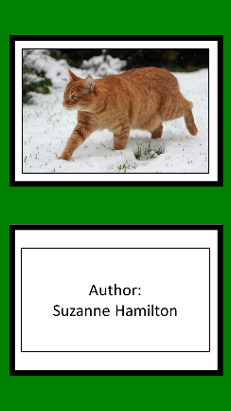
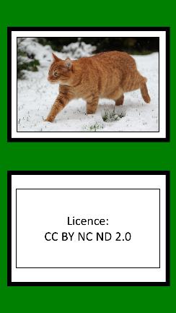
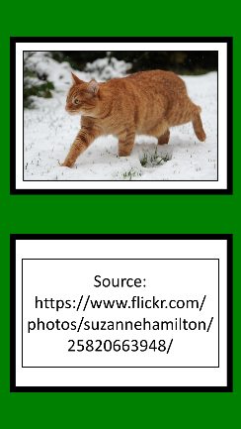

On your turn
- Draw a card
Take a card from the deck and discard one of your other cards
- Add to the commons
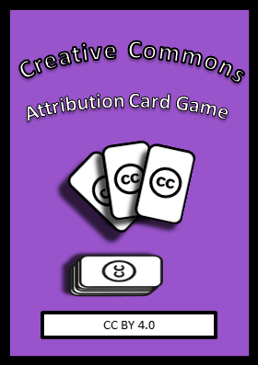
Take a card from the deck and add it to the shared cards ion the table. Anyone can use this card.
- Invite a swap
You can ask another player to swap a card with you. Remember they can say no!

