‘Maddie is Online’ Links and Resources



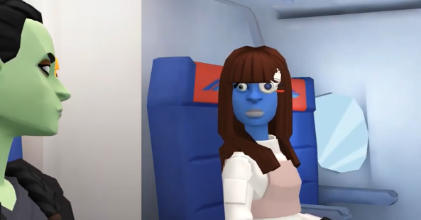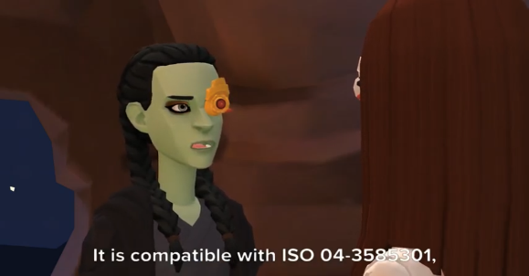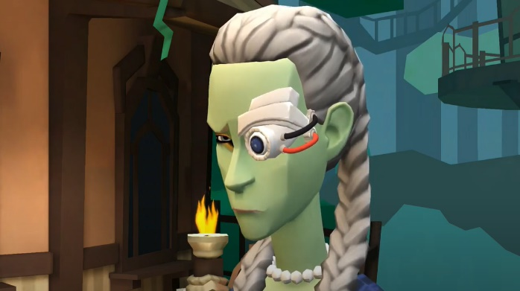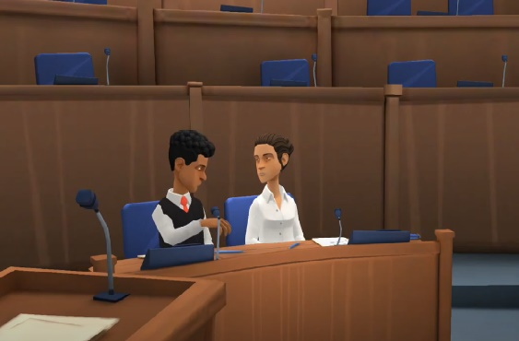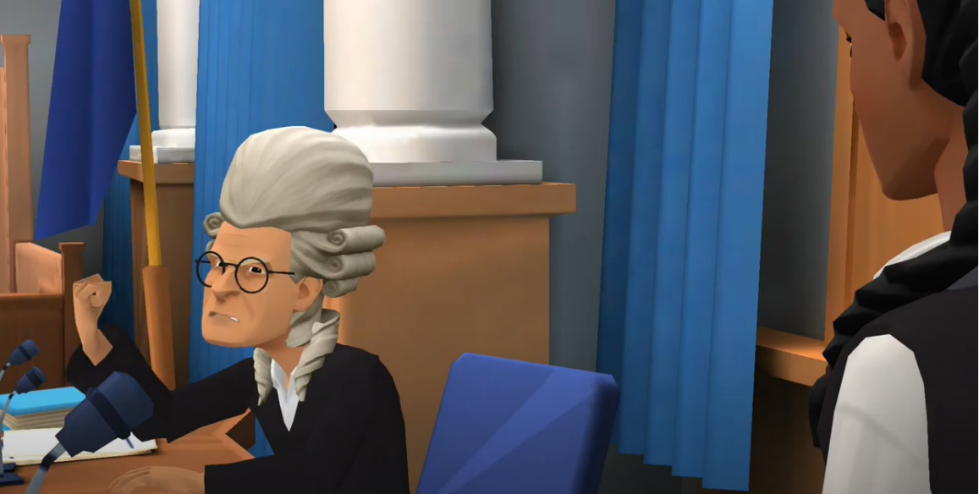

Icepops pre-session preparation

Please watch the following videos in advance of the session if possible.

Series 3 Copyright Playlist is available via: https://youtube.com/playlist?list=PLlUx8jQ1MCcTk-CMNdp_IZQMIF9gZw7JM (5 out of 8 episodes of this series have been released).

Video Testimonials of Student Interns on Series 3 Copyright

Emma Grey: https://youtu.be/ADtGwVXThMo

Niall McDonald: https://youtu.be/wiqqQbrLVo8

Article by Dalia Garcia (playing the alien Pinachu in Series 3 Copyright): Voice-over for 'Maddie Is Online', Digital Literacy Project | News | Students | The University of Aberdeen (abdn.ac.uk)

Links to recent publications and presentations on this work

#LibrariesAreEssential to Young People’s Digital Literacy (cilips.org.uk)

“Maddie is online”: an educational video cartoon series on digital literacy and resilience for children | Emerald Insight

Robert Gordon University Innovation Accelerator Clip: https://youtu.be/2W73GZUxL5s

OneHE Presentation on ‘Maddie is Online’ project: https://youtu.be/ebnUVCnWXoM
Links to access of all ‘Maddie is Online’ material
Project Blog: https://maddiesonline.blogspot.com/
Playlists: bit.ly/2LwnE6T
Recourses Booklets:
- Series 1 Online Resilience: https://www.slideshare.net/martzoukou/maddie-is-online-series-1-booklet-with-resources-244677681
- Series 2 Misinformation: https://www.slideshare.net/martzoukou/maddie-is-online-series-2-misinformation-booklet-updated
- Series 3 Copyright booklet will be available later on in the summer. Please keep an eye on the project blog.
Twitter: @MaddiesOnline
Email: k.martzoukou@rgu.ac.uk
Recent Successes
Semi-finalist in Converge Impact Challenge: New Inventions from Scotland’s Universities Could Change Life as We Know It – Converge Challenge Converge is funded by the Scottish Funding Council, all 18 of Scotland’s universities, Creative Scotland and a network of partners including Cisco, The Royal Bank of Scotland and Social Investment Scotland.

